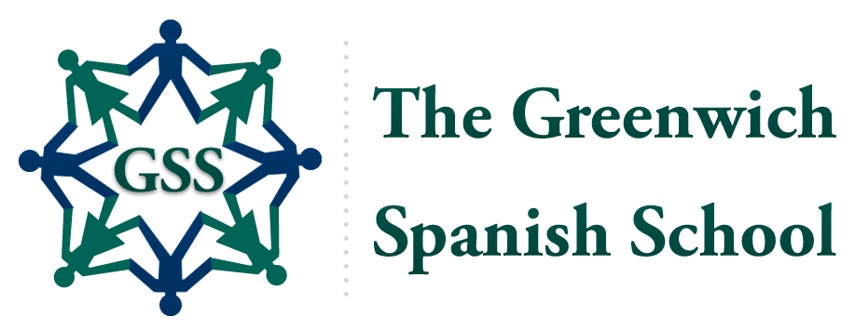
2022
Summer
Programs

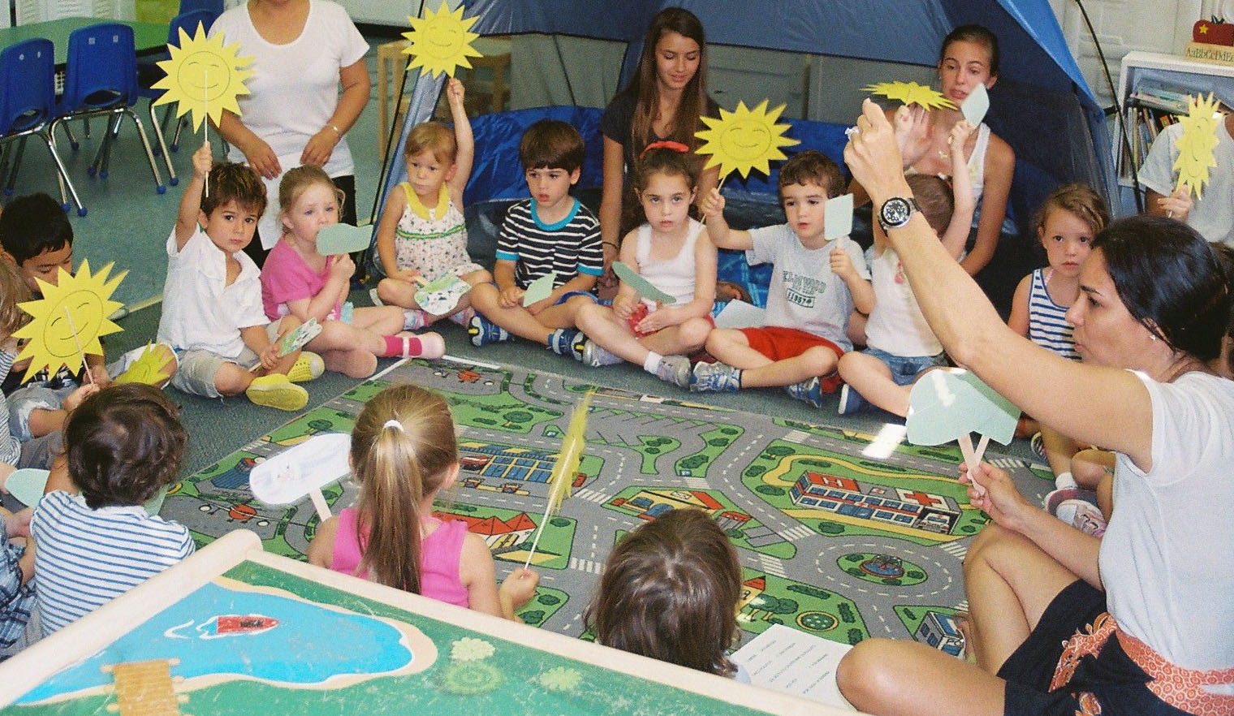

✰ Fun, creative programs and activities to
introduce children to another language
✰ Arts, crafts, music, dance, outdoor and
cultural activities – all in Spanish!

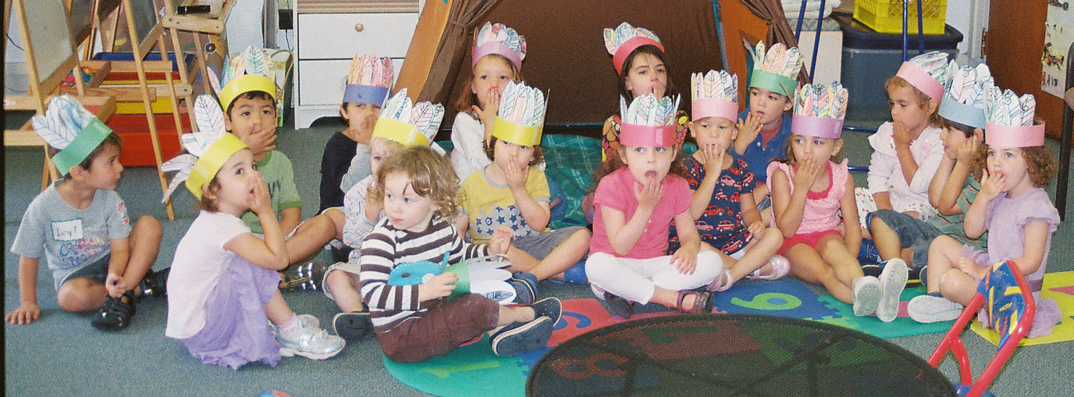
- For children 3-5 and 6-10 years old
- No prior knowledge of Spanish needed
- Visit www.GreenwichSpanish.org for details

The Greenwich Spanish School
is located in St. Agnes Parish – 247 Stanwich Road
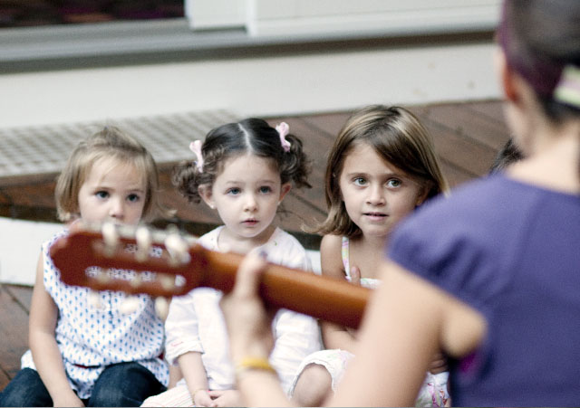
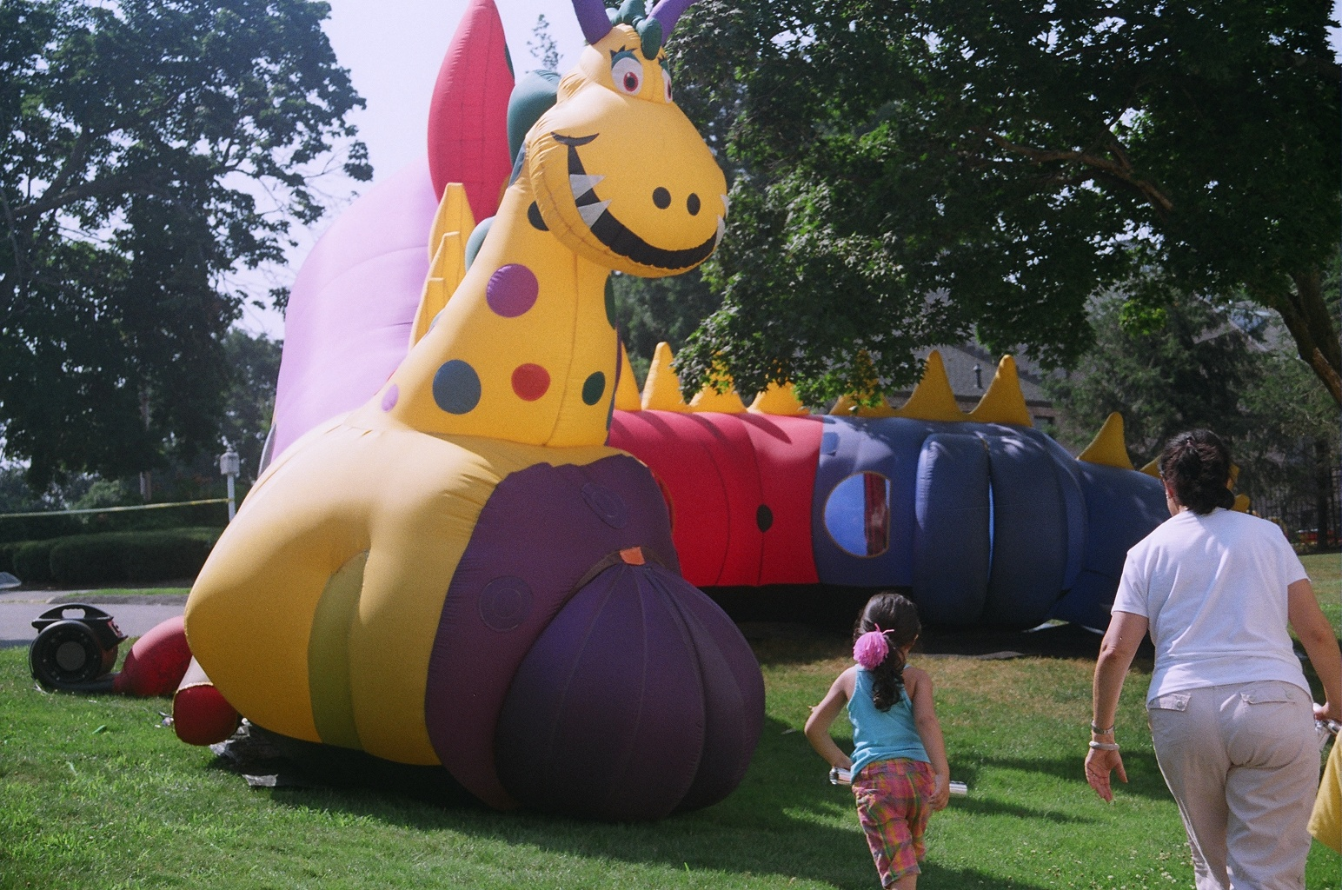
Greenwich CT 06830
Contact:
Rosario J. Brooks, Director
(203) 698-1500
Rosario@GreenwichSpanish.org
Licensed by the CT Dept of Health

Summer Program Schedules
First Session June 6 – 17 3-10 years Half day: Mon - Fri 9:00 am to 12:00 pm
3-10 years Full day: Mon - Fri 9:00 am to 3:00 pm
Second Session June 20 – July 1 3-10 years Half day: Mon - Fri 9:00 am to 12:00 pm
3-10 years Full day: Mon - Fri 9:00 am to 3:00 pm
Third Session July 11 – 22 3-10 years Half day: Mon - Fri 9:00 am to 12:00 pm
3-10 years Full day: Mon - Fri 9:00 am to 3:00 pm
Fourth Session July 25 – Aug 5 3-10 years Half day: Mon - Fri 9:00 am to 12:00 pm
3-10 years Full day: Mon - Fri 9:00 am to 3:00 pm
Fifth Session August 8 - 12 3-10 years Half day: Mon - Fri 9:00 am to 12:00 pm
3-10 years Full day: Mon - Fri 9:00 am to 3:00 pm

(Children are also welcome for single weeks)

Program Fees Half day: $250 per child per week - $495 per child per 2-week session
Full day: $495 per child per week - $990 per child per 2-week session
★ All teachers and assistant teachers are native or have native fluency in Spanish.
★ All volunteers are fluent in Spanish.

